MANDATORY: You must use a headset approved by the Translation Bureau to appear by videoconference
Witnesses appearing before a Senate committee by videoconference must use one of the headsets approved by the Translation Bureau. If you do not use one of the approved headsets, you will not be able to testify before the committee. Use of an approved headset ensures optimal sound quality for simultaneous interpretation and helps protect interpreters from hearing-related injury.
The Translation Bureau’s list of approved headsets can be found on their website here. Please note that the Senate of Canada’s preferred model is the Jabra Evolve2 40 USB or SE, linked below.
*PREFERRED MODEL*
Jabra Evolve2 40 USB
Jabra Evolve2 40 SE

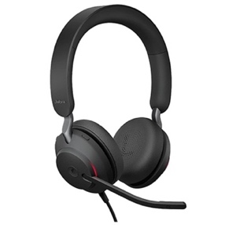

If you are unable to obtain the preferred model, please consult the Translation Bureau’s list for alternative options. Please make sure you have sufficient time before your appearance for shipping, and please advise the committee clerk before your appearance if you need to purchase one or if you require accommodations.

REIMBURSEMENT:
Following your appearance before the committee, you may submit a claim for reimbursement to the committee clerk — up to a maximum of $250 before taxes and shipping — using the Witness Expense Claim Form, which can be found on the Useful Resources for Witnesses page. A proof of purchase must be submitted with your claim. Should you have financial or other considerations that may affect your ability to acquire a headset or if you require accommodations, please contact the committee clerk; it may be possible to make alternative arrangements.

ALTERNATIVE HEADSET Models APPROVED BY THE TRANSLATION BUREAU*:
*Approved models are subject to change by the Translation Bureau. Please carefully verify your selection on the Translation Bureau’s website here before purchasing an alternate headset.

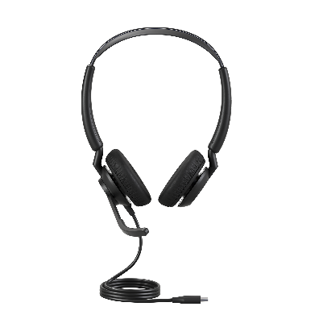  Jabra Engage 50 II | 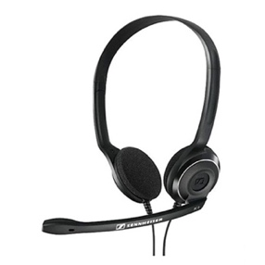  EPOS/Sennheiser PC-8 USB | 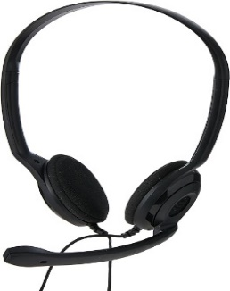  EPOS/Sennheiser PC Chat 5 3.5 mm
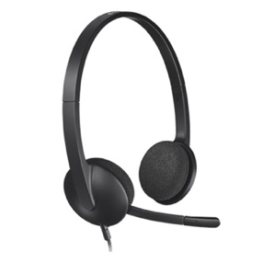  Logitech H340 USB | 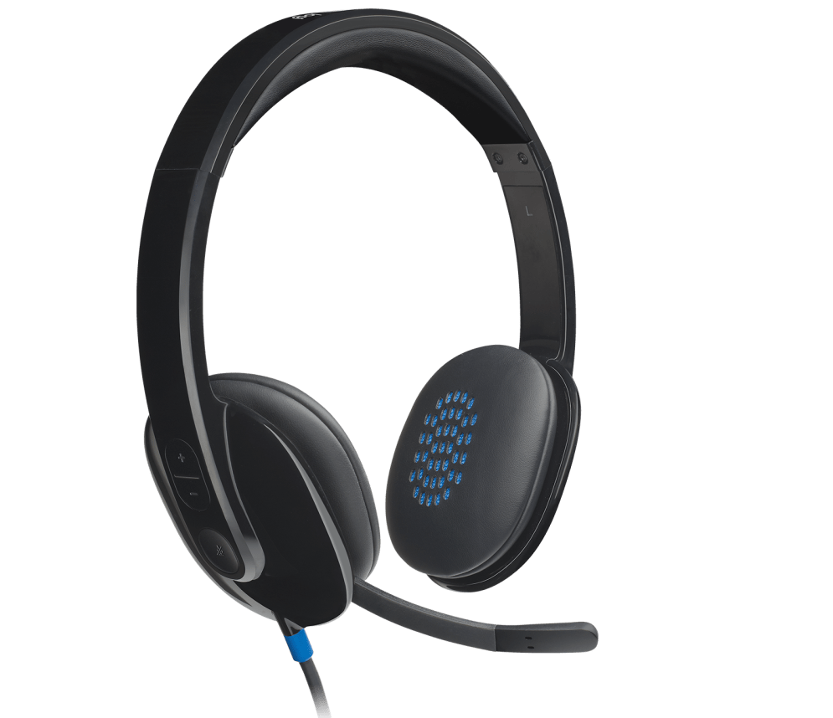  Logitech H540 USB | 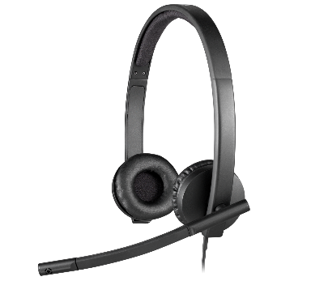  Logitech H570e USB
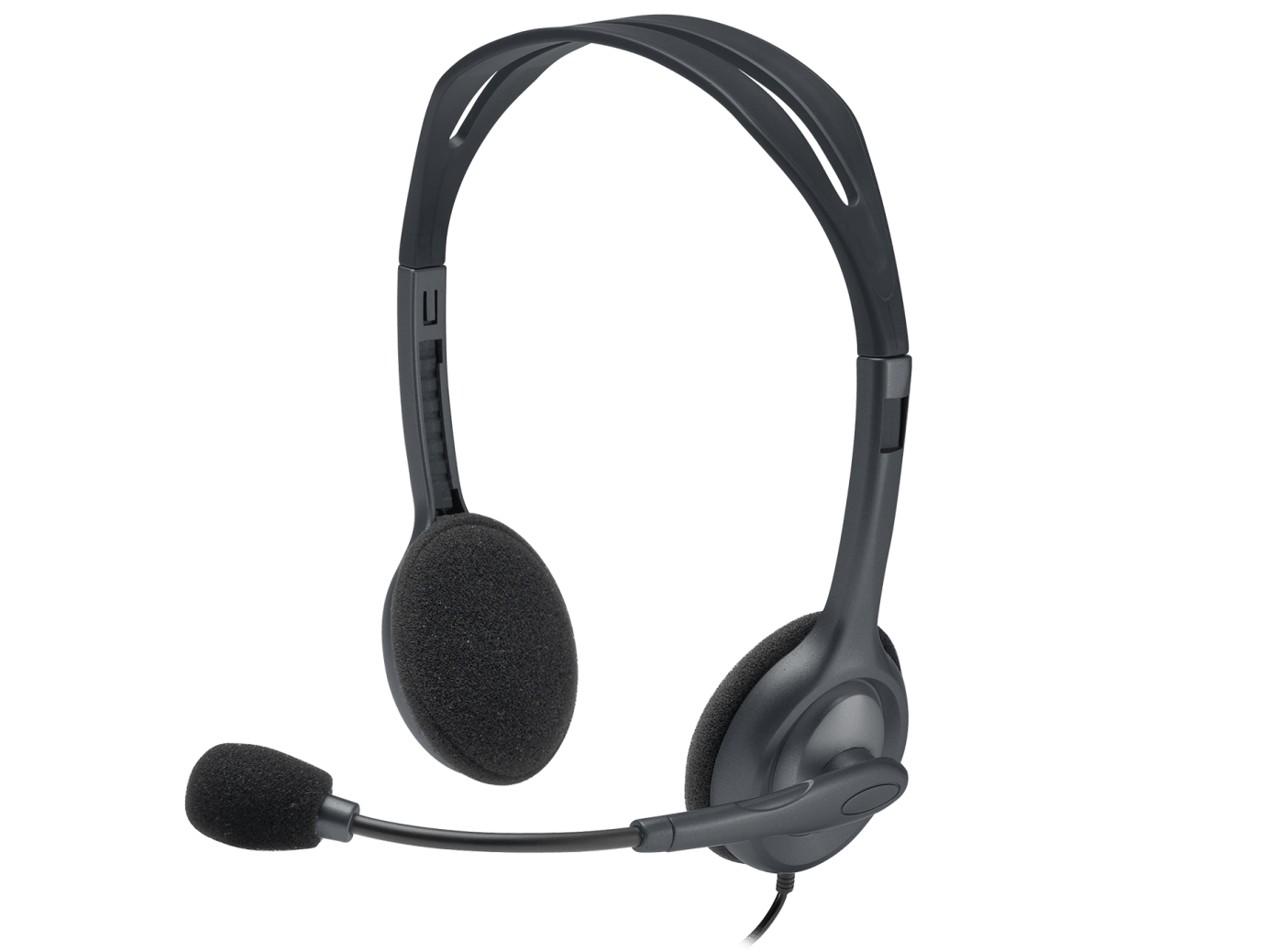  Logitech H111 3.5 mm | 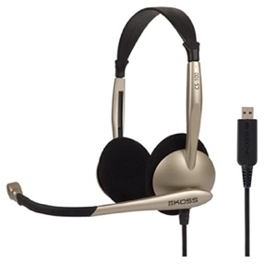  Koss CS100 USB | 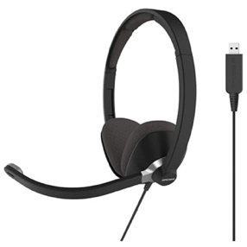  Koss CS300 USB
Please note that the above hyperlinks to headset suppliers are not an endorsement by the Senate of any particular vendor. Witnesses may purchase an approved headset from any supplier, including from the manufacturer. These links have been provided simply to assist witnesses in identifying the specific models that have been approved by the Translation Bureau for use by virtual meeting participants.

You can find the contact information for committee clerks on the web page for each committee, in the “Contact/About” section. Please note that any hyperlinks to headset suppliers are not an endorsement by the Senate of any particular vendor. Witnesses may purchase an approved headset from any supplier, including from the manufacturer. These links have been provided simply to assist witnesses in identifying the specific models that have been approved by the Translation Bureau for use by virtual meeting participants.

